Cece Geisler
CSD325
Module 9.2 Assignment
February 18, 2026

Install requests
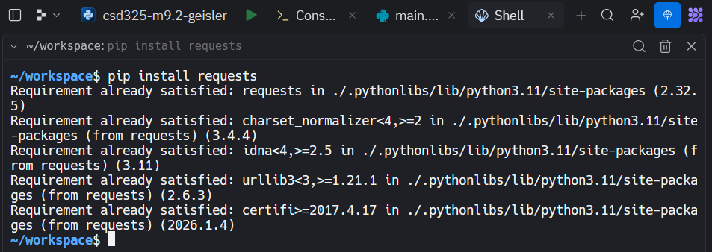

URL Test - Success
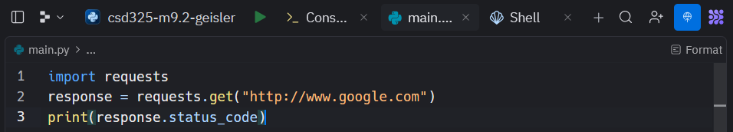
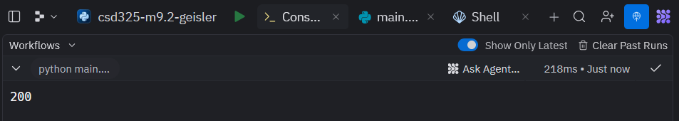

Retrieving Current Astronauts and Formatting Output
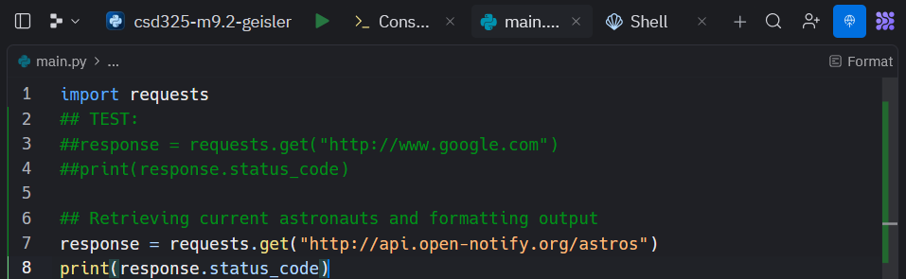
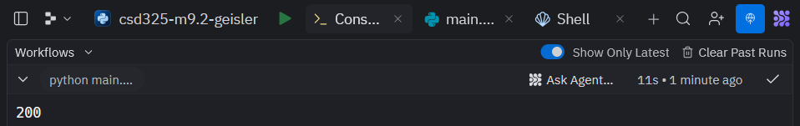
The above screenshot shows I am connected to the “astros” API.
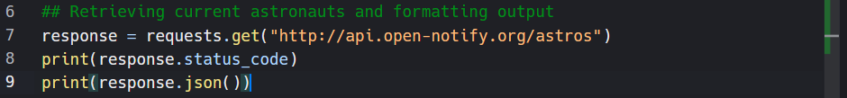
Trying to view the data
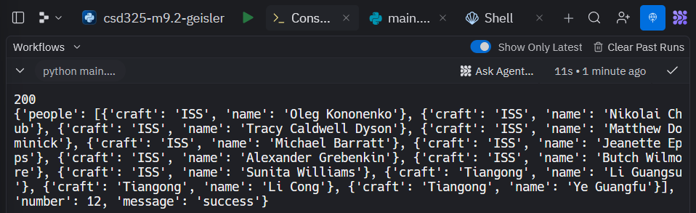
There are 12 current astronauts.

Creating My Own Program

Testing Connection to Simple API and Printing Results Without Formatting
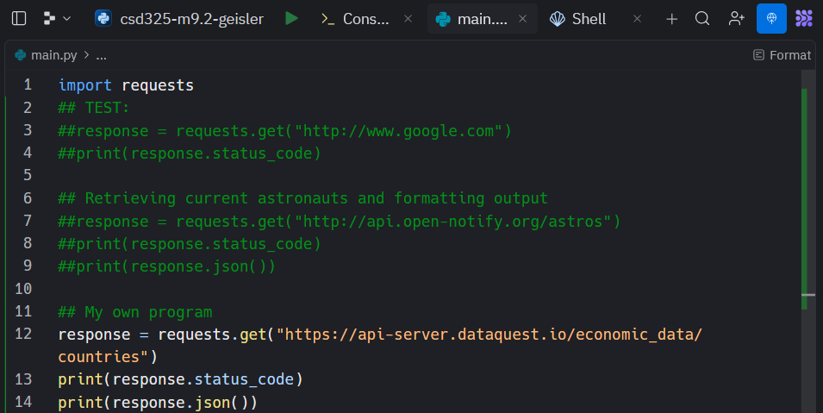
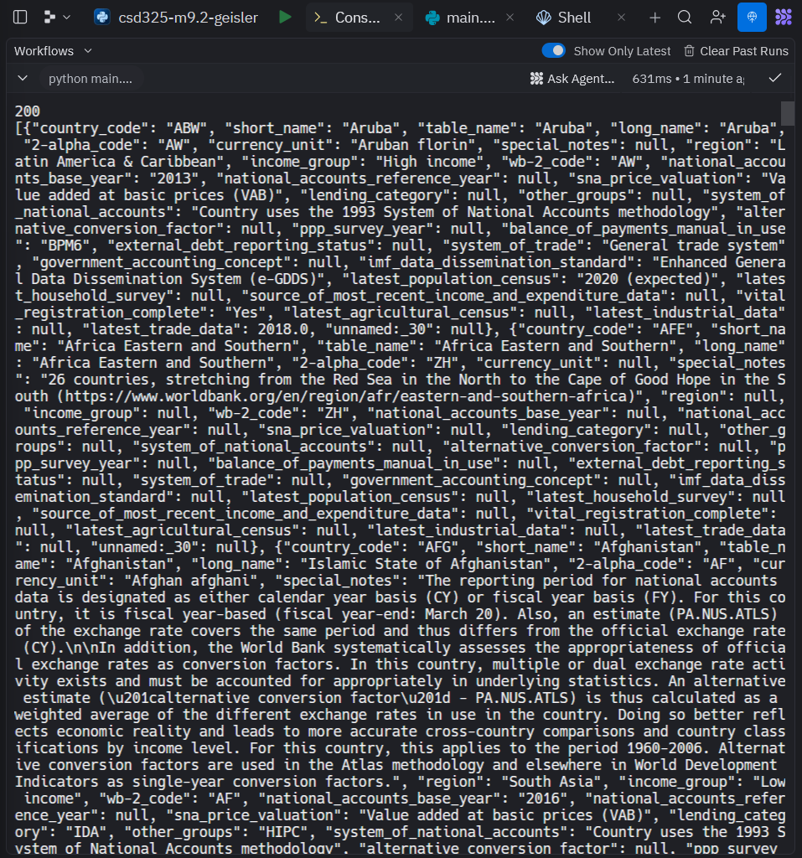

Printing Response with Same Formatting as Tutorial Program
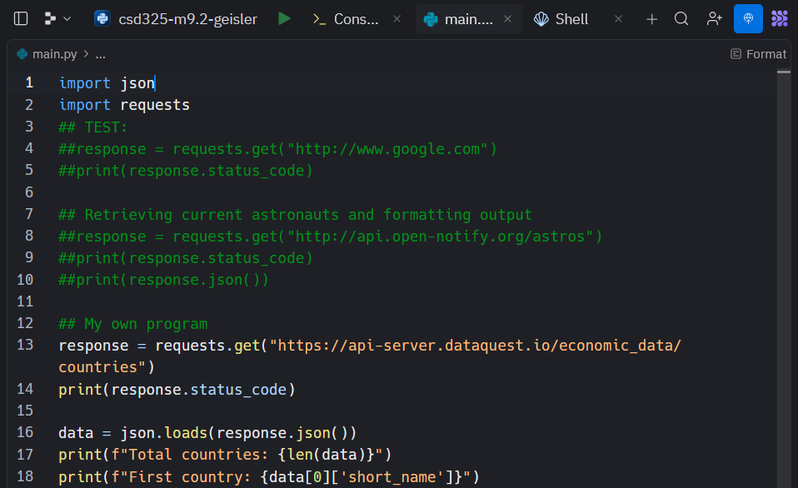
Results:
